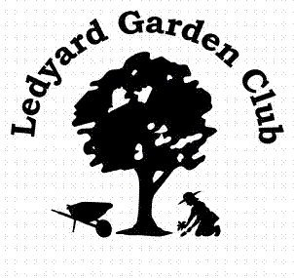
Ledyard Garden Club Annual Plant Sale
Ledyard Garden Club Annual Plant Sale at the Ledyard Congregational Church Hall, 722 Colonel Ledyard Highway, Ledyard, CT. “50 Years of Growing with Us.
Saturday, May 17, 2014, 8:30 a.m. to 12 Noon
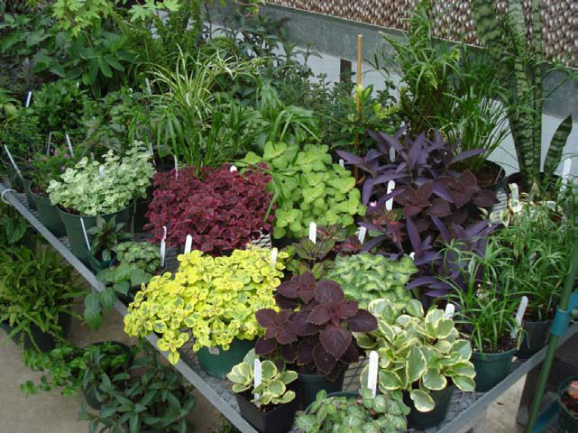
The sale features perennials, annuals, shrubs, grasses, ground covers, vegetables and herbs. Many are dug from members’ gardens or grown by the Ledyard high School Ag Sci students. The prices are reasonable and there are helpful gardeners on site. Bring a friend (or two). Free and open to the public. Proceeds benefit the Lester House Gardens, local youth scholarships and other community gardens that the group maintains.

