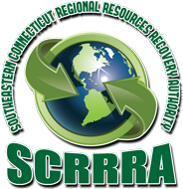

Southeastern CT Regional Resources Recovery Authority
Location: Gales Ferry Landing

All programs are FREE
Call 860-381-5558 to register

Make a Recycled Bracelet - Just in time for Mother’s Day. Just bring in a magazine (that will be cut up) – SCRRRA will provide everything else. May 7 & 10, 10:00 a.m. to 12:00 p.m.
Plant a Flower – Come in and plant a flower; another Mother’s Day item. May 10, 10:00 a.m. to 12:00 p.m.
Presentation: Where does my trash go? – May 17, 10:00 a.m. and May 20, 6:00 p.m.
Organic Gardening – Courtney Kolakowski, NOFA Accredited Organic Land Care Professional/Master Gardener, will be doing a kpresentation on Organic Gardening using natural and organic products. May 3, 10:00 a.m. and May 13, 6:00 p.m.
Plant a Herb – Just in time for Father’s Day. Come in and plant a herb – SCRRRA will provide all that is needed. June 7, 10:00 a.m. to 12:00 p.m.

