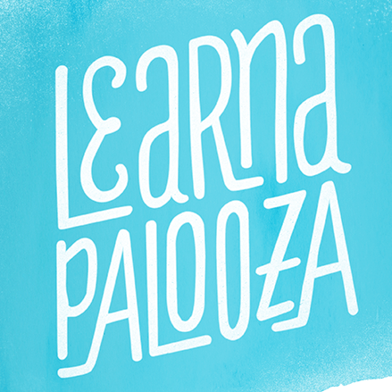

Ledyard Parks and Recreation and Ledyard Public Libraries are planning a learning day next March and are looking for presenters who have a skill or talent they would be willing to present. Skills could include things like bee-keeping, soap making, scrap-booking, car maintenance, composting, cake decorating, Zumba, yoga or some other activity. The possibilities are endless. Presenters will have 30-45 minutes in which to present their skill with time afterwards for questions. Participants will be able to choose from a list of activities during an allotted time period throughout the day. If you have a talent or skill you wish to present, please fill out the Presenter Form and return it to either the Parks and Recreation Office or Libraries or by email to:
kim@ledyardrec.org

