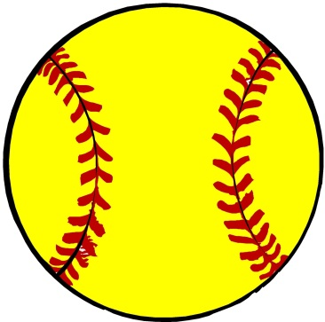
Ledyard Colonels
Youth Softball Clinic
The Ledyard High School softball team will be conducting a softball clinic for youth players in all surrounding areas. This clinic will cover the fundamentals needed in throwing, catching, fielding, hitting, bunting, and base-running. The pitcher/catcher clinic will have beginner stations and advanced stations. All are welcome!

When: March 18th- T-ball, Instructional, & first year U-10
March 19th- Second year U-10, U-12, and Junior League
March 20th- All interested in pitching and catching
Time: 6:00-7:30 each night
Where: Ledyard Middle School Gymnasium
Fee: $10 per player
Pre-registration is not necessary, but it will help us plan for the clinic!
If you would like to pre-register or have any questions please contact Coach Brittany Connors at connors017@connect.wcsu.edu
*There will also be a bake sale at each clinic!!

