Thursday, June 29th | $19.00
Mystic Cinemas | The first field trip of the summer is a quick trip to the movies! Campers will be in a theater, designated just for our camps to see the new Elemental movie. Campers will receive a complimentary bag of popcorn and a juice box!
Tuesday, July 11th | $17.00
Niantic  Children’s  Museum | Discovering things is fun! Campers will be given the chance to go through multiple themed rooms during this trip. They will have time on the playground and even a chance to make some arts & crafts!
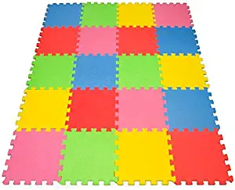  Tuesday, July 18th | $18.00
ABC  Gymnastics | Kids love to tumble, and we love to make them happy! So, we’re taking them to ABC Gymnastics where they can run around, jump into the foam pit, and play in the ball pit!
Tuesday, July 25th | $17.00
Strawberry  Park | One of our favorite field trips is back!!! Campers will be heading to Strawberry Park where they will get to swim in a pool, play in a Splash Pad, go on the playground, and enjoy the day in the sun!
Tuesday, August 1st | $17.00
Nature  Center | Campers will get to spend the day at the Denison Pequotsepos Nature center! They will learn about animals and habitats along with walking some of the nature trails!

